Project Design Phase-II
Data Flow Diagram & User Stories

Date | 16 February 2026
Team ID | LTVIP2026TMIDS87366
Project Name | Prosperity Prognosticator: Machine Learning for Startup Success Prediction
Maximum Marks

Data Flow Diagrams:
A Data Flow Diagram (DFD) represents how data moves through the startup prediction system. It shows how user input is processed, how the machine learning model predicts the result, and how the output is displayed.
In this system, the user enters startup-related information such as funding details, milestones, and relationships. This data is processed by the Flask application and passed to the trained machine learning model. The model predicts whether the startup will be acquired or closed, and the result is displayed to the user.

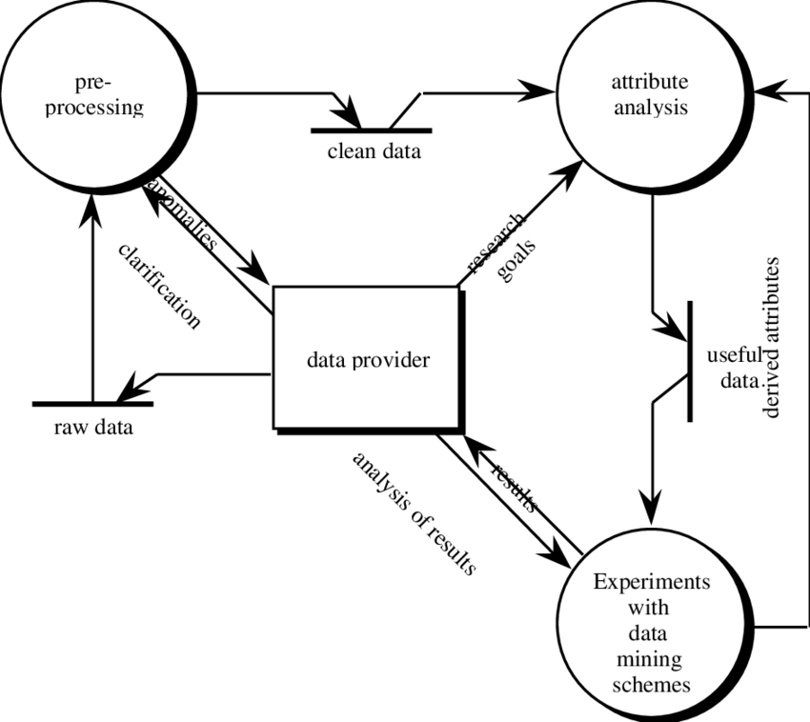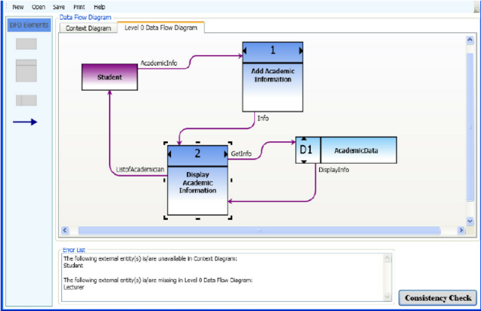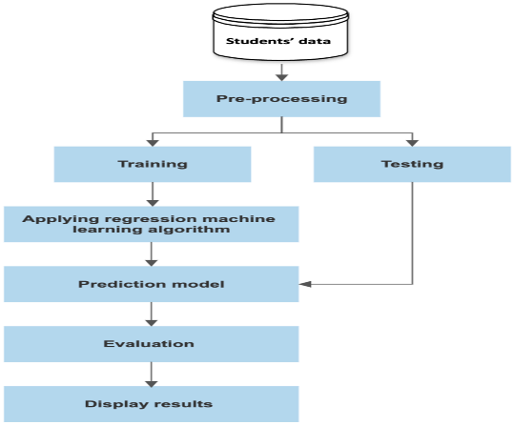

Figure: Data Flow Diagram for Startup Success Prediction System

User Stories

User Type | Functional Requirement (Epic) | User Story Number | User Story / Task | Acceptance criteria | Priority | Release
WEB User/Startup User | Startup Prediction | USN-1 | As a user, I can enter startup details in the form to get prediction results. | User can input data and click predict to see result. | High | Sprint-1
 | Result Display | USN-2 | As a user, I can view whether the startup is acquired or closed. | Prediction result appears clearly on result page. | High | Sprint-1
 | Confidence Score | USN-3 | As a user, I can see prediction confidence percentage. | Result page shows percentage value. | Medium | Sprint-1
 | Input Validation | USN-4 | As a user, I receive a message if any field is empty or invalid. | Form shows validation message. | Medium | Sprint-1
Administrator | Model Update | USN-5 | As an admin, I can update the trained model  file. | New model replaces old model successfully. | Medium | Sprint-2
 | System Maintenance | USN-6 | As an admin, I can ensure the application runs properly | New model replaces old model successfully. | Low | Sprint-2

